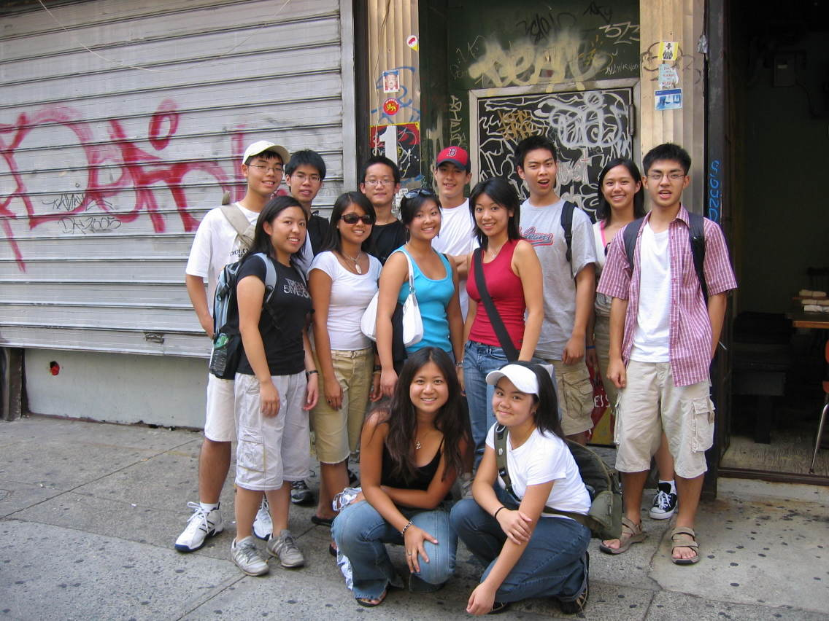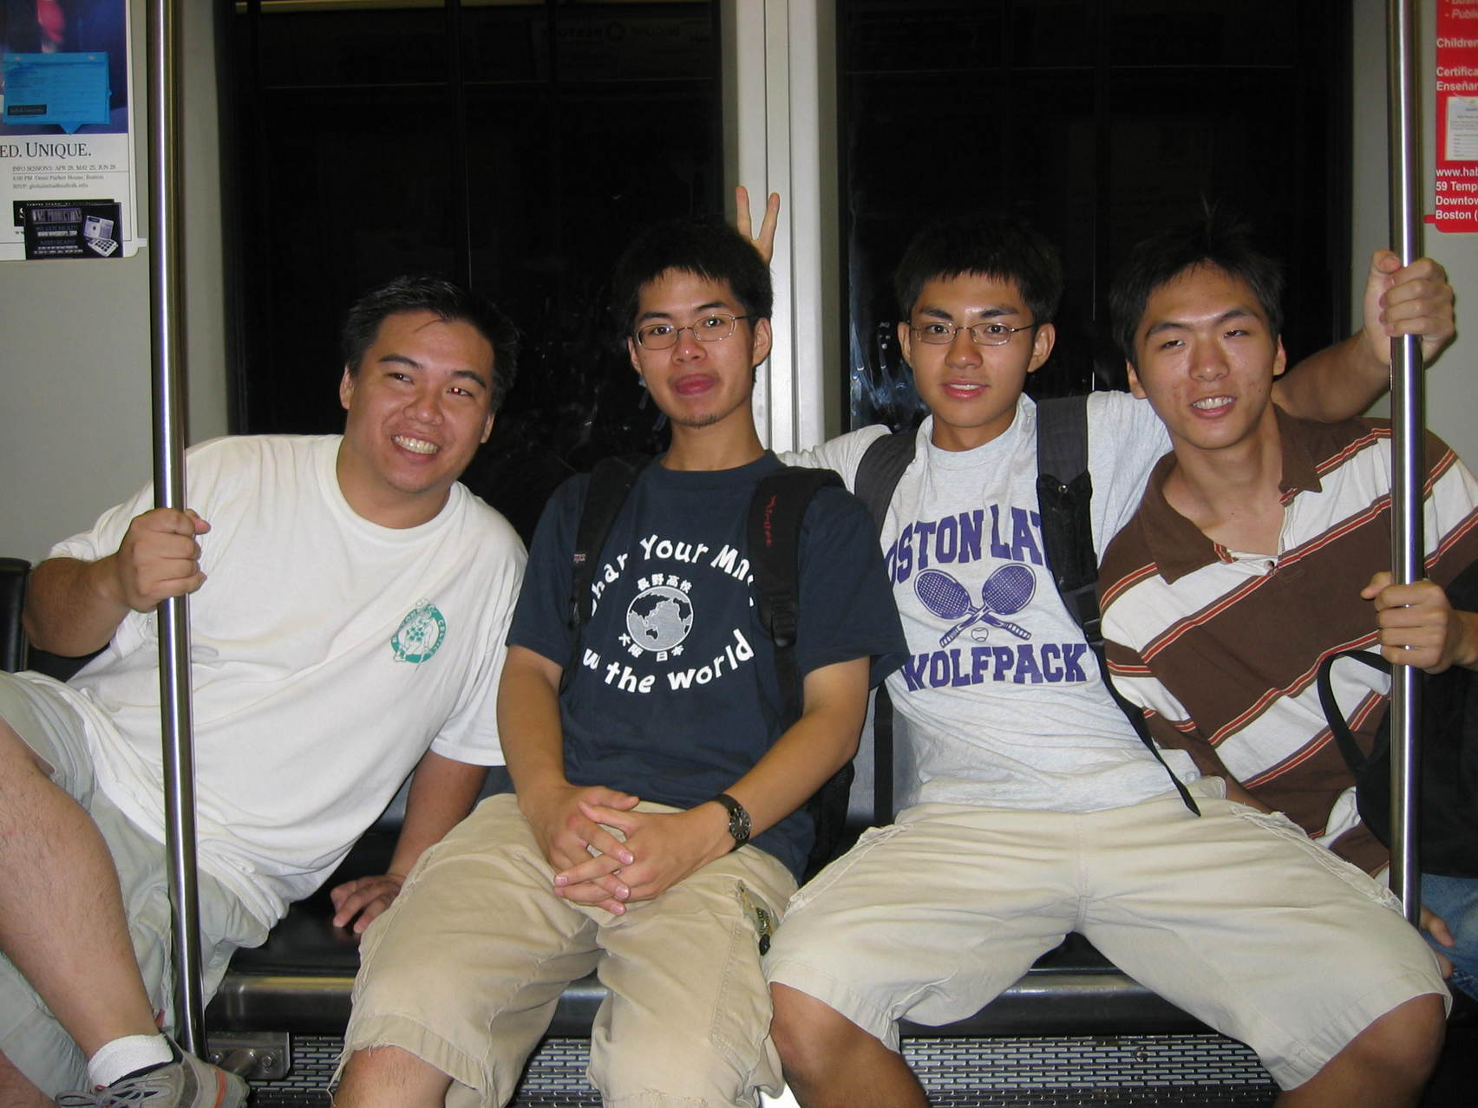

Are you a high school-aged youth interested in the CYI paid summer internship?
你是否一位對華人前進會青年動力項目暑期實習有興趣的青年？

Applications due or postmarked by April 5th, 2017
(Application and Interview required)
截止申請日期為 2017 年4月5日
（申請者必須要填寫申请表格和接受面试）

For more information please contact:
若有問題，請與青年協調員聯絡

Mark Liu
Chinese Progressive Association
28 Ash Street, Boston, MA 02111
(617) 357-4499 or e-mail: mark@cpaboston.org

Important Dates/Timeline
重要日期/時間表

April 5th: Applications due or postmarked
4月5日：申請表截止日期

April 17 – 28th: Interviews
4月17日至28日：面試

Early-Mid May : Decisions on acceptance
5月中：通知面試結果

June 17th: Chinatown Bike-A-Thon
6月17日：华埠骑自行车活动

July 5th-7th: Overnight retreat
7月5日至7日：退思會

July 10th: Internship begins Mondays-Thursdays
7月10日：實習開始 ，星期一至星期四

What is the Chinese Youth Initiative (CYI)?
The mission of the Chinese Youth Initiative is to develop youth leadership in the Chinese American community. Since 1994, CYI has been educating youth about the issues that Chinese Americans face, and has been providing youth with experience in grassroots organizing. CYI is a program of the Chinese Progressive Association based in Chinatown. It has opportunities year round, including a summer internship program.

What is CYI’s Summer Internship Program?
The internship program is an opportunity to understand the issues Chinese Americans face and how we can take collective action to improve our lives! By learning about Asian American history, Chinatown, and the core principles of organizing, you will be grounded in the community and what it takes to make transformative change. The CYI Summer Internship is a seven-week experience for high school-aged youth that focuses on the experiences and issues of Chinese Americans in the Greater Boston area. Through interactive workshops, discussions, videos, guest speakers, field trips, and hands-on projects, you will develop a deeper understanding of yourself, others, and the community. You will also not just be learning, but taking action! This can include education projects, outreach to community members, and attending and planning protests. Issues that past youth have worked on in the past include worker rights, affordable housing, and a Chinatown library. Youth who have a strong investment in their community, who are bilingual in Chinese, and come from immigrant families are strongly encouraged to apply.

You will find out by early May if you are accepted into the program and there will be an orientation scheduled for late May or early June. All accepted applicants will be expected to participate in the Chinatown Bike-A-Thon, Saturday, June 17th. The internship kicks off with an overnight retreat from Wednesday, July 5th to Friday, July 7th, 2017 and will meet on Mondays through Thursdays from 10:00am to 4:00pm from Monday July 10th to Thursday August 17th, 2017. In addition to the dates and times listed, participants must be able to commit to some weekend and evening activities, averaging 20-25 hours per week. Interns will receive a stipend of $280 every two weeks for the duration of the summer program. Overnight retreat and other sessions after retreat are mandatory for participation.

青年動力項目是什麼（CYI）？
青年動力項目的宗旨是在華裔社區裡培養青年領袖。自1994年以來，CYI一直教育青年認識有關華裔所面對的問題，並一直向青年提供基層組織的經驗。CYI是波士頓華人前進會的一個工作項目。一年四季運作，其中包括暑期實習計劃。

CYI的暑期實習計劃是什麼？
一個可以發掘你領導潛能，了解華埠及認識如何組織社區的項目！ CYI暑期實習是一個長達七週，發展高中生年齡青年的領導力，並提供機會去改變華人社區。實習項目是專注於華裔在大波士頓地區的經驗和問題，通過互動研討會，討論，視聽，演講嘉賓，實地考察和實踐項目，參加者從而得到知識和工具去成為社區領袖。在實習的最後幾個星期裡，實習生會制定一個社區行動項目，並給予機會反思和分享他們在學習中累積的知識。如果你對我們的社區有無限的熱忱，是中英雙語，以及來自移民家庭，我們極之鼓勵你來參加。

如果你被取錄參加青年互動項目，會在五月初收到消息，和在五月尾或六月初會有介紹會。所有被取錄的申請人必須參加在星期六 6 月 17 日舉辦的自行車馬拉松籌款活動。實習項目會隨著在7月5日至7月7日的退思會而揭幕，之後是由7月10日至8月17日，逢星期一至四，上午10時到下午4時聚會。除了上述的日期和時間外，參與者必須參加一些週末和晚上的活動，平均每週大概20-25小時。實習生將會在這段期間內每兩週獲得$280的津貼。而所有退思會及所有其他會議必須要參與。

Background Information
背景資料

English name英文名字: _______________________________________________________________________
Chinese name中文名子：_____________________________________________________________________
Home Address地址: __________________________________________________________________________
City/State/Zip城市/州/地區:___________________________________________________________________
Phone Number電話號碼______________________________________________________________________
Email電子郵件: _____________________________________________________________________________
Date of Birth出生日期: _______________________________________________________________________
School學校: _________________________________________________________________________________
Grade level年級 : _____________________________________________________________________________
Please list any languages or dialects that you speak (other than English)
除了英文意外，你會說什麼語言: ______________________________________________________________
Interests/Hobbies愛好: _______________________________________________________________________
How did you hear about this program (e.g. personal reference, relative, school, community organization, website, etc.)?
您是怎麼知道這個計劃的 （比如說：有人介紹，親戚，學校，社區組織，網頁）?

___________________________________________________________________________________________

What times are you available between April 17-28 for an interview?

___________________________________________________________________________________________

- Getting to know you! (Please respond to the follow questions below on a separate piece of paper)
認識一些關於你的情況！ （請回應以下的問題）

  - Why do you want to be a participant in the CYI Summer Program?
你为什么要参加暑期的青年动力项目实习班？

  - Respond to ONE of the following three questions in audio, visual or written form (e.g. video, essay, song, poem, etc.). If written, please write at least two paragraphs. Feel free to get creative! Responses can be submitted in English or Chinese.
請用錄音，錄影或書寫的方式回答下列任何一題。你可以自由發揮，用中文或英文的形式作答。

    - What is your life like as an Asian American (if applicable)? How does your race/ethnicity affect your life?
作為一個亞裔，你的生命是怎樣的？（如果適合，可作答）。你的種族/族裔如何影響著你的生命？

    - What is something you have done that you are most proud of? Why?
你做了一些什麼事情是令你感到驕傲的？ 为什么？

    - What is an injustice that you want to change? Why and how would you do it?
有些什麼不平等的事情是你想有改變的？爲什麽？你會如何改變這些事情？

  - Enclose a copy of your résumé (or a list of your co-curricular activities, jobs, club activities, other commitments and responsibilities, interests, skills, etc.)
請附上你的履歷（或一份列出你的課外活動，工作，小組活動，其他承諾和責任，興趣，特長等）

  - Optional: You may provide a letter of recommendation from someone (who is not related to you) who can comment on why this program is a good fit for you. Submit it to CYI directly or include it with your application in a signed envelope.
可選擇：你可以提交一份推薦書（該推薦人是與你不相關的），這人會陳述這個計劃為什麼是適合你。推薦書可以連同申請表一起放入信封內，直接交給青年動力項目。

Email your completed application form and related application materials to mark@cpaboston.org or mail them postmarked by April 5th, 2017 to:

請將完成的申請表及有關申請文件在2017年4月5日前電郵到mark@cpaboston.org 或郵寄到

CYI Summer Internship Program
Chinese Progressive Association
28 Ash Street
Boston, MA 02111

