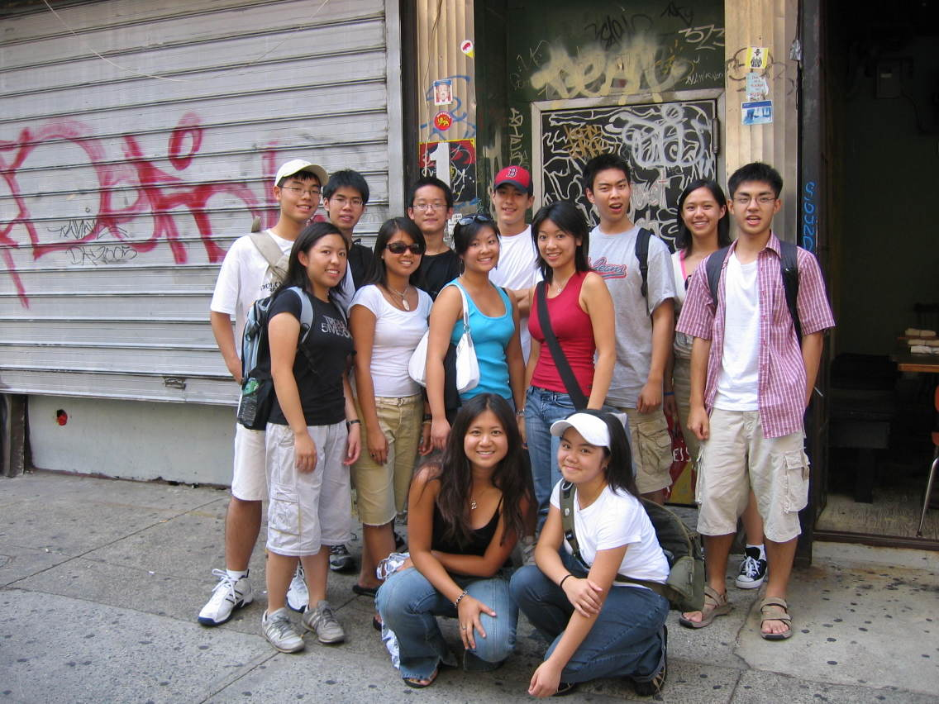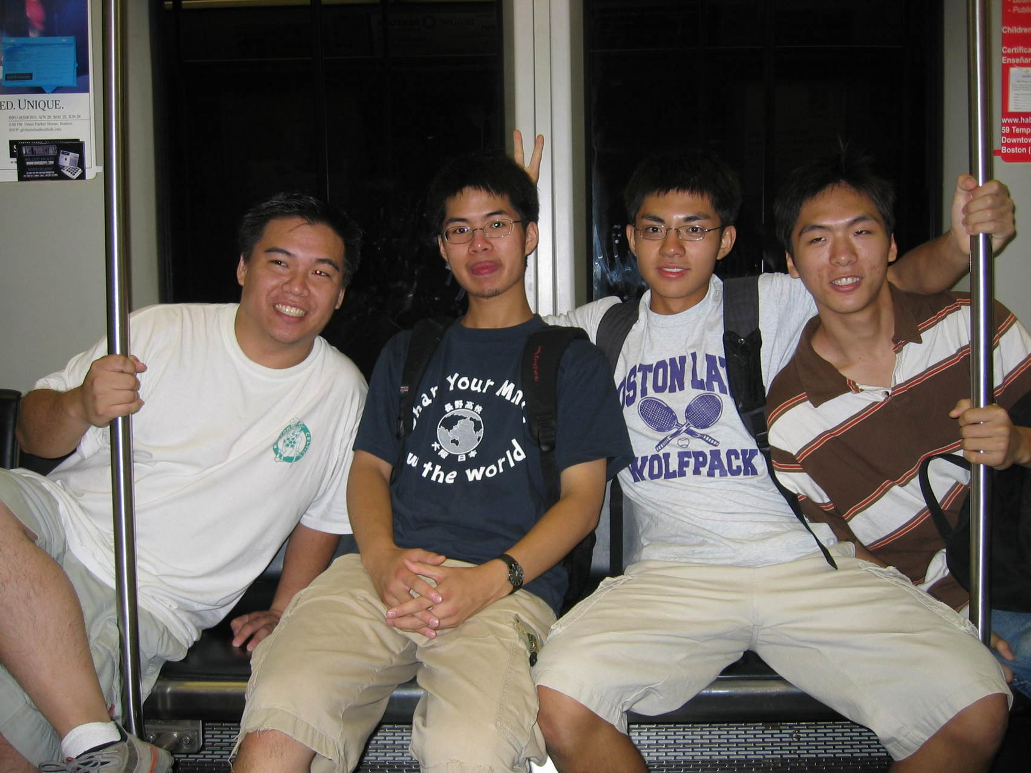

***Bringing together Chinese American Youth from all over the Boston area***

Chinese Youth Initiative is seeking high school-aged youth interested in our paid summer opportunity!

*Applications due or postmarked by April 11th, 2014*

(Application and Interview required)

For more information please contact the Youth Coordinator, Kimberly Situ at:

Chinese Progressive Association

28 Ash St.

Boston, MA 02111

phone: (617) 357-4499

e-mail:kim@cpaboston.org

**What is the Chinese Youth Initiative (CYI)?**

The mission of the Chinese Youth Initiative is to develop youth leadership in the Chinese American community. Since 1994, CYI has been educating youth about the issues that Chinese Americans face, and has been providing youth with experience in grassroots organizing. CYI is a program of the Chinese Progressive Association based in Chinatown. It has opportunities year round, including a summer internship program.

**About CYI’s Summer Internship Program**

This is an intensive, seven-week, summer internship that develops the leadership of high school-aged youth to get involved in the Chinatown community. The internship focuses on the experiences and issues of Chinese Americans in the Greater Boston area. Through interactive workshops, discussions, videos, guest speakers, field trips, and hands-on projects, participants are given the knowledge and tools to become leaders in the community. In the final week of the internship, participants will have an opportunity to reflect on and share their learning in a cumulative event. **Youth who have a strong investment in their community, who are bilingual in Chinese, and come from immigrant families are strongly encouraged to apply**.

The internship kicks off with an overnight retreat from **Sunday June 29th to Tuesday July 1st, 2014** and will meet on Mondays through Thursdays thereafter from 10:00am to 3:30pmfrom **Monday July 7th to** **Thursday August 21st, 2014**. In addition to the dates and times listed, participants must be able to commit to some weekend and evening activities, totaling 20-25 hours per week. Interns will receive a stipend every two weeks for the duration of the summer program. Overnight retreat and all other sessions are mandatory for participation.

**Important Dates/Timeline**

April 11th, 2014: Applications due or postmarked

Late April-Early May: Interviews

Mid-May: Decisions on acceptance

June 29th: Summer Intern’s Retreat

July 7th: Internship Begins!

1. **Background Information**

English name: Click here to enter text.

Chinese name (If applicable): Click here to enter text.

Home Address: Click here to enter text.

City/State/Zip: Click here to enter text.

Phone Number: Click here to enter text.

Email: Click here to enter text.

Date of Birth: Click here to enter a date.

School: Click here to enter text.

Grade level (in Fall 2013): Choose an item.

Please list any languages or dialects that you speak (other than English): Click here to enter text.

Interests/Hobbies: Click here to enter text.

Are there times between April 19-27 when you are **NOT** available for an interview? If yes, what times?

1. **Getting to know you!** *(Please attach responses to the following questions to this application form)*
   1. Why do you want to be a participant in the CYI Summer Program? How did you hear about this program (e.g. personal reference, relative, school, community organization, website, etc.)? *Response should be between 150-300 words.*
   2. Respond to ONE of the following three questions in audio, visual or written form (e.g. video, essay, song, poem, etc.) Feel free to get creative!
      1. Describe what a typical day is like for you as a Chinese American (if applicable). What are some highlights and/or challenges?
      2. Why is Chinatown an important community? What does it mean to you?
      3. Tell us about a time when you made a significant positive impact in someone’s life or when someone made a significant positive impact in your life.
   3. Enclose a copy of your résumé (or a list of your co-curricular activities, jobs, club activities, other commitments and responsibilities, interests, skills, etc.)
   4. *Optional*: You may provide a letter of recommendation from someone (who is not related to you) who can comment on why this program is a good fit for you. Submit it to CYI directly or include it with your application in a signed envelope.

Email your completed application form and related application materials to kim@cpaboston.org or mail them postmarked by **April 11th, 2014** to:

CYI Summer Internship Program

Chinese Progressive Association

28 Ash St

Boston, MA 02111

Got questions? Contact Kimberly Situ at (617) 357-4499 or via email at kim@cpaboston.org.

Good luck!